Unit 10 Circle Review Guide 2020 Name:________________

Drawings of examples are good.

1. What is the difference between an inscribed angle and a central angle in terms of its location and relation to the intercepted arc?

2. What is a tangent line and how can you verify that a line is tangent to a circle? (theorem)

3. What is the difference between a secant and a chord?

4. What is the difference between a sector and an arc?

5. Solve for r. 6. What value of r would make the line

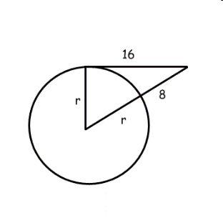tangent?

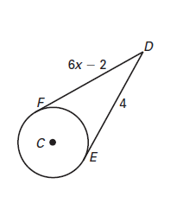7. Find the value of the angle. 8. Solve for x.



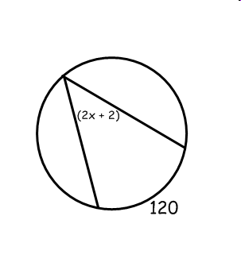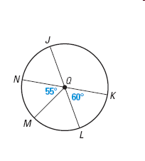9. Label the value of all the arcs. 10. Solve for x.

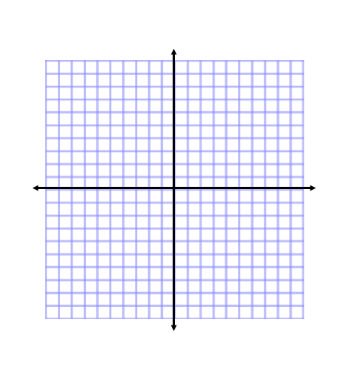11. The equation of a circle with a center of (-5, 3) and a diameter of 5. Graph the circle.

12. Give the equation of the circle with a center of (3,2) and the point (5,2) is located on the circle.

Find the variable(s)

13. 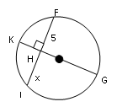 14.

F

H

J

x

K

G

5

A

E

D

C

B

4x – 6

10

15. 16.

60°

x°

y°

200

A

E

D

C

B

10x°

80°

17. 18.

120°

x°

y°

50°

G

E

F

35°

x°

y°

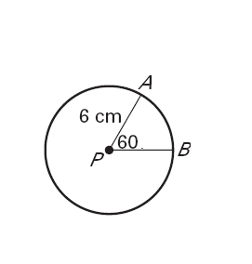19. Find the arclength of  and the area of Sector *AB*.

Arclength  = _______________

W

A

C

N

O

D

Y

K

20. Name 2 **chords**.

21. Name 2 **diameters**.

22. Name 2 **radii**.

23. Name 2 **minor arcs**.

24. Name 2 **major arcs**.

25. Name 2 **semicircles**.

26. Name 2 **tangents**. 28. Name 2 **secants**.

27. Name 2 **inscribed angles**. 29. Name 2 **central angles**.